Mall Girl Meets the Shadow Vandal: Reading Guide
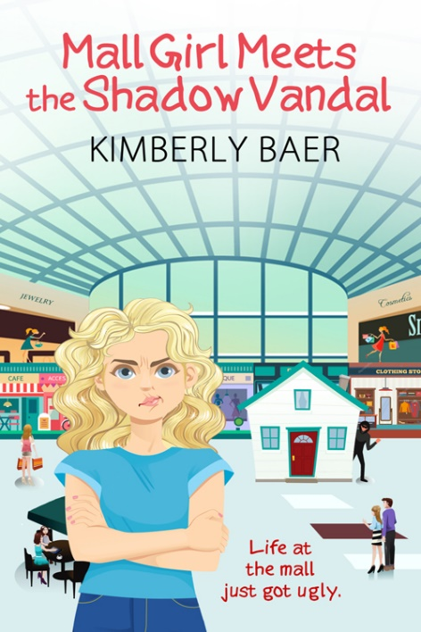

Pre-reading
1. Study the front cover of Mall Girl Meets the Shadow Vandal. Describe what you see.
Click or tap here to enter text.
2. Based on the title and the picture on the front cover, what do you think the story is about?
Click or tap here to enter text.
3. Read the blurb (a description of the story) on the back cover. (If you don’t have a print copy of the book, you can find the blurb here.) Does the blurb match the story the front cover is telling? Did it change your idea of what the story is about?
Click or tap here to enter text.
4. View the Mall Girl book trailer on YouTube. How is it different from the front cover and the back-cover blurb?
Click or tap here to enter text.
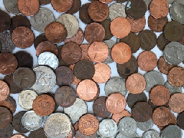

Chapters 1-5
Comprehension questions
1. What unusual situation is described on page #1 of Mall Girl Meets the Shadow Vandal?
Click or tap here to enter text.
2. What is the main source of conflict between Chloe and her mom, based on their conversation in chapter 2?
Click or tap here to enter text.
3. List some things you learned about Chloe in the first five chapters of the book.
Click or tap here to enter text.
4. Why does Jack Caldwell think Ursula might be the vandal? (Ch. 3)
Click or tap here to enter text.
5. Why do you think Ursula puts a question mark at the end of “We’re not guilty, right?” instead of stating it as a fact? (Ch. 5)
Click or tap here to enter text.
Discussion questions
- If you could meet Chloe, what questions would you ask her?
- If people kept throwing coins down your chimney, what would you do with the money?
- Why do you think Ursula tells Chloe to go to the pool with “some other friend,” even though Chloe has told her over and over that Lindy is her only friend?
- If you were in Chloe’s position, would you tell the police about the missing eggs? Why or why not?
- Would you like to live at the mall? Why or why not?

Chapters 6-10
Comprehension questions
1. Ursula cried when her measuring spoon broke. Was that the real reason for her tears? Explain. (Ch. 6) Click or tap here to enter text.
2. What is Chloe’s theory about why she doesn’t have many friends? (Ch. 8)
Click or tap here to enter text.
3. Why is Chloe upset to learn she’s not in the same academic section as Lindy? (Ch. 8)
Click or tap here to enter text.
4. Why do you think Chloe refuses to run after Lonnie Davis and her cousin? (Ch. 9)
Click or tap here to enter text.
5. Why does Chloe consider it a “problem” that she knows half the kids in her class? (Ch. 10)
Click or tap here to enter text.
Discussion questions
- Under the law of eminent domain, the government can force people to sell their land so that a public building, such as a shopping mall, can be built on it. Do you think this is a fair law? Why or why not?
- Why do you think Chloe has recurring nightmares about spiders? Brainstorm for ideas.
- How do you think Ron would have reacted if Chloe had told him about the missing eggs?
- How important do you think it is to live near your friends?
- Based on the first ten chapters of the book, do you think Chloe and her mom have a basically good relationship or a basically bad relationship? Give evidence for your answer.

Chapters 11-15
Comprehension questions
1. Why does Robby think Chloe is a new student? (Ch. 11)
Click or tap here to enter text.
2. On the first day of school, Chloe notices that Lindy’s shoes are very different from hers. What does this hint at regarding the state of their friendship? (Ch. 11)
Click or tap here to enter text.
3. Why do you think Chloe used to pretend the ladies’ clothing department in Farringer’s was a forest? (Ch. 12)
Click or tap here to enter text.
4. What does Chloe do that shows she has started to think of Robby as a friend? (Ch. 13)
Click or tap here to enter text.
5. Why does Chloe decide to tell the Mystery Groupers about the Shadow Vandal? (Ch. 15)
Click or tap here to enter text.
Discussion questions
- Why do you think Robby picks Chloe, and not somebody else, to be his new friend?
- How do you think the Shadow Vandal is getting into the Lamonts’ house to steal eggs? Brainstorm for ideas.
- Does it surprise you that Robby likes Ash? Why or why not?
- Imagine that Robby, instead of Chloe, lived at the mall. How might his experience be different from hers? Would he hate living at the mall as much as she does?
- Do you think Chloe or her mom could be the Shadow Vandal? Discuss your evidence.
Photo by Luis Villasmil on Unsplash.com
Chapters 16-21
Comprehension questions
1. Why doesn’t Chloe want to move downtown, even though that would mean she wouldn’t have to live at the mall anymore? (Ch. 16)
Click or tap here to enter text.
2. Why does Chloe kick the knife under the stove? (Ch. 17)
Click or tap here to enter text.
3. Chloe’s heart “seems to slide up into [her] throat” when she sees the knife on the floor. Find other descriptions from chapter 17 that show how anxious Chloe and Ursula are.
Chloe: Click or tap here to enter text.
Ursula: Click or tap here to enter text.
4. What does Chloe mean by “T-shirt Girl is beginning to plump out, like a balloon filling with air”? (Ch. 18)
Click or tap here to enter text.
5. According to Ron, why does Jack Caldwell want the Lamonts to move out of the mall? (Ch. 19)
Click or tap here to enter text.
Discussion questions
- The Shadow Vandal used eggs in his first two attacks. Why do you think he switched to a knife for the third attack?
- Why do you think Ursula acted so cold to Chloe after Officer Sanford and Ram left?
- Why is Chloe creeped out by her cellar? Brainstorm for ideas.
- Read Chloe’s T-shirt poem. Do you think it’s too long, too short, or just right? Is anything missing? Would you do anything differently if it was your poem?
- Robby says Chloe’s poem is “a mix of happy and sad.” Do you agree? What makes it happy? What makes it sad?
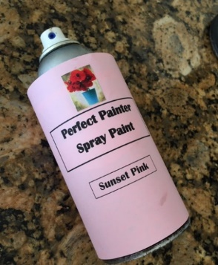

Chapters 22-26
Comprehension questions
1. Robby doesn’t seem disappointed to get second place instead of first in the Creative Endeavors contest. Based on what you know about him, does his reaction make sense? Explain. (Ch. 22)
Click or tap here to enter text.
2. Why does it seem unlikely that the Shadow Vandal entered the Lamonts’ house after the spray paint attack, even though Hal is convinced he did? (Ch. 23)
Click or tap here to enter text.
3. What are the police officers looking for as they search the Lamonts’ house? (Ch. 24)
Click or tap here to enter text.
4. Why might Prisha and Carlie be hoping Ash wins the poetry contest dispute? (Ch. 26)
Click or tap here to enter text.
5. How does Mr. Hutzell offend Carlie and her parents? (Ch. 26)
Click or tap here to enter text.
Discussion questions
- Who do you think the Shadow Vandal might be—a stranger, or a character you’ve already met? Make a guess.
- Mr. Hutzell thinks the school should disqualify Chloe’s poem because it’s made up of sayings written by other people. Do you agree with him? Why or why not?
- Compare Ash’s poem to Chloe’s, Prisha’s, and Carlie’s. Do you think Ash should have won a prize?
- Do you feel sorry for Ash because she lost the poetry contest dispute? Why or why not?
- If you entered a contest but didn’t win a prize, would you want your parents to protest the results? Give your reasons.
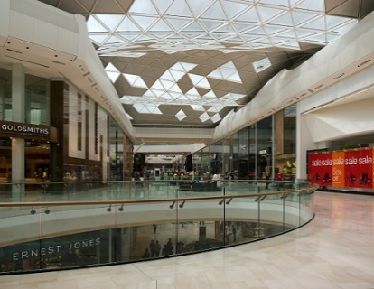
Photo by Brett Jordan, Unsplash.com
Chapters 27-31
Comprehension questions
1. What interesting item does Chloe find in her mom’s outgoing mail pile? (Ch. 27)
Click or tap here to enter text.
2. Why did Kenny and Kevin want to hold the movie event at Chloe’s house? (Ch. 28)
Click or tap here to enter text.
3. What sad situation do Chloe and Ash have in common? (Ch. 29)
Click or tap here to enter text.
4. Why didn’t anyone tell Chloe and her friends that the mall was being evacuated? (Ch. 30)
Click or tap here to enter text.
5. Why is Kevin upset about having to stay with the girls instead of exploring the secret passageway with his brother and Robby? (Ch. 31)
Click or tap here to enter text.
Discussion questions
- Do you think Chloe was right to open her mother’s mail?
- Were you surprised by any of the things Ash told Chloe as they waited for Robby to come back with Chloe’s mom? Explain.
- The Mystery Groupers decide to look for an unlocked door so they can escape from the mall. Can you think of other ways they might have escaped?
- Would you say the Mystery Groupers have a leader, and if so, who is it? Is there more than one? Look for passages that show one or more of the characters taking a leadership role as they try to find their way out of the mall.
- If you were trapped in the mall with the Mystery Groupers, would you want to look for unlocked exits with Chloe and Ash or explore the secret passageway with the boys? Give your reasons
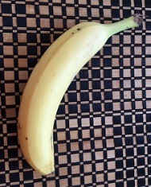

Chapters 32-37
Comprehension questions
1. What evidence proves that the Shadow Vandal has been using the secret passageway to get in and out of Chloe’s house? (Ch. 32)
Click or tap here to enter text.
2. Why is Chloe horrified to see the Shadow Vandal looking at the fireplace poker? (Ch. 33)
Click or tap here to enter text.
3. Why did the Shadow Vandal steal merchandise from the mall in his final attack? (Ch. 34)
Click or tap here to enter text.
4. Chloe has always hated her curly hair, but near the end of the story, she decides she likes it. Why? (Ch. 35)
Click or tap here to enter text.
5. How were Chloe and her mom like “bananas in strange places” throughout much of the story? (Ch. 36)
Click or tap here to enter text.
Discussion questions
- What do you think would have happened between Chloe and the Shadow Vandal if Ash hadn’t come back and sprayed him in the face with bug spray?
- Because of the Shadow Vandal’s attacks on the mall, an effort gets underway to bring the downtown area back to life. Does this make the Shadow Vandal a hero instead of a villain? Discuss your reasoning.
- Were you surprised that Chloe and Ash became friends? Why or why not?
- Chloe is happy to finally be living in a normal neighborhood. So why does she feel sad as she watches her former home being torn down?
- Were you surprised to learn the identity of the Shadow Vandal? Were there any clues in the story that pointed to that character? Did you or anyone else in your group guess correctly?

